**Literature Review Report**

**Executive Summary**

**Introduction**

Automation of farm activities can transform agricultural domain from being manual and static to intelligent and dynamic leading to higher production with lesser human supervision. This paper proposes an automated irrigation system which monitors and maintains the desired soil moisture content via automatic watering. Microcontroller ATMEGA328P on arduino uno platform is used to implement the control unit. The setup uses soil moisture sensors which measure the exact moisture level in soil. This value enables the system to use appropriate quantity of water which avoids over/under irrigation. IOT is used to keep the farmers updated about the status of sprinklers. Information from the sensors is regularly updated on a webpage using GSM-GPRS SIM900A modem through which a farmer can check whether the water sprinklers are ON/OFF at any given time. Also, the sensor readings are transmitted to a Thing speak channel to generate graphs for analysis.

**Outline of Methodological Approach**

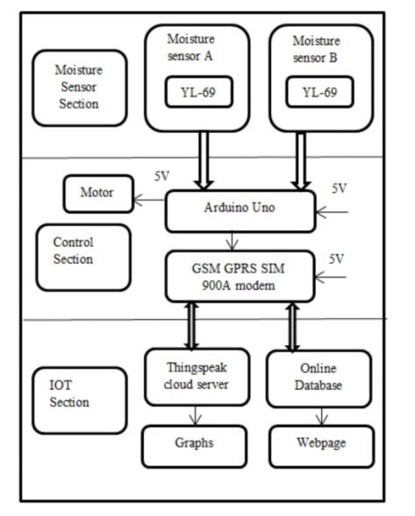

**Identification, Selection and Analysis of the Literature**

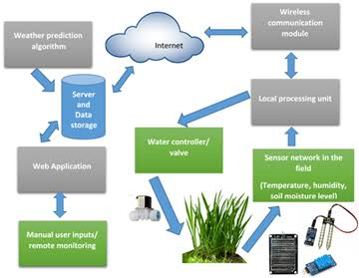

**Findings**

The attached sensors will find the various situations of the soil and based on soil moisture percent, land gets automatically irrigated. It means when field needs water then automatically motor will get ON and it will get OFF when it’s get enough. These sensed parameters and motor status will be displayed on user devices. These have been running successfully. It will reduce the farmer pore as well. By this type of Smart Irrigation System we can save water and we can maintain soil moisture percent, and it reduces power loss of humans.

**Conclusion and Future Work**

A system to monitor moisture levels in the soil was designed and the project provided an opportunity to study the existing systems, along with their features and drawbacks. The proposed system can be used to switch on/off the water sprinkler according to soil moisture levels thereby automating the process of irrigation which is one of the most time consuming activities in farming. Agriculture is one of the most water-consuming activities. The system uses information from soil moisture sensors to irrigate soil which helps to prevent over irrigation or under irrigation of soil thereby avoiding crop damage. The farm owner can monitor the process online through a website. Through this project it can be concluded that there can be considerable development in farming with the use of IOT and automation. Thus, the system is a potential solution to the problems faced in the existing manual and cumbersome process of irrigation by enabling efficient utilization of water resources

**References**

[1] Csótó, Magyar, “Information flow in agriculture – through new channels for improved effectiveness”, Journal of Agricultural Informatics 1 (2), 25–34, 2010

[2] R.Suresh, S.Gopinath, K.Govindaraju, T.Devika, N.SuthanthiraVanitha, “GSM based Automated IrrigationControl using Raingun Irrigation System”, InternationalJournal of Advanced Research in Computer and Communication Engineering Vol. 3, Issue 2, February 2014

[3] Sumeet. S. Bedekar, Monoj. A. Mechkul, and Sonali. R. Deshpande “IoT based Automated Irrigation System”, IJSRD - International Journal for Scientific Research& Development| Vol. 3, Issue 04, 2015 | ISSN (online): 2321- 0613